

Blackdown Nursing Home

Introduction

Goodness September is here! We have had a very productive summer growing our own herbs, tomatoes and sunflowers. The sun has shone, and we have been able to enjoy our outside space. This month we have talks booked, ponies and Animal HQ and return visit from the pigmy goats. A busy month ahead.

Forthcoming Events

2nd September – Singer Paul Stevens at 2pm
4th September – Wendy Wellness at 11.30am Singer Patrick at 2pm
10th September - Wendy Wellness at 11.30am
11th September – Singer Jon Nicholas at 11am
12th September – Pastoral Service with Josie at 11am
15th September – Animal HQ at 11am
16th September
– Talk from Salvation Army at 2pm
17th September – Craft day
18th September – Podiatrist, Singer Paul Stevens at 2pm
19th September – Cooking with Fiona
22nd September – Dartmoor Carriages at 2pm
25th September – Singers Bob & Tony at 2pm
26th September – Pastoral Service with Josie at 11am, Talk from Dartmoor Search and Rescue at 2pm
30th September – Tavistock Therapy Goats at 2pm

The Hairdresser will be in Tuesday 2nd September and then back to Wednesday’s on 10th & 24th and on holiday on 17th.

Fundraising Update

We had a fantastic summer fair, and Jon Nicholas played his guitar creating a lovely atmosphere. Staff joined in the fun playing games adorning coloured sunglasses and floral garlands. Raising £162.50 for our resident’s fund. Thank you for your support and contributions.

The resident’s fund has boosted our Activity Program paying for:
Fish and Chips
Ben’s Ice Creams
Yoga with Fran
Tavistock Therapy Goats
Dartmoor Carriage Ponies
50% towards the Christmas Panto

Home Update

The upstairs flooring installation is now 1st – 3rd of September, please bear with us Monday – Wednesday.

Staff News
Congratulations to:
Basil on his recent Wedding
Jack on completing his L3 qualification

Warm welcome to Claire who has joined our Housekeeping team.
Welcome back to Ancelet form her maternity leave

A selection of photos from Events in August
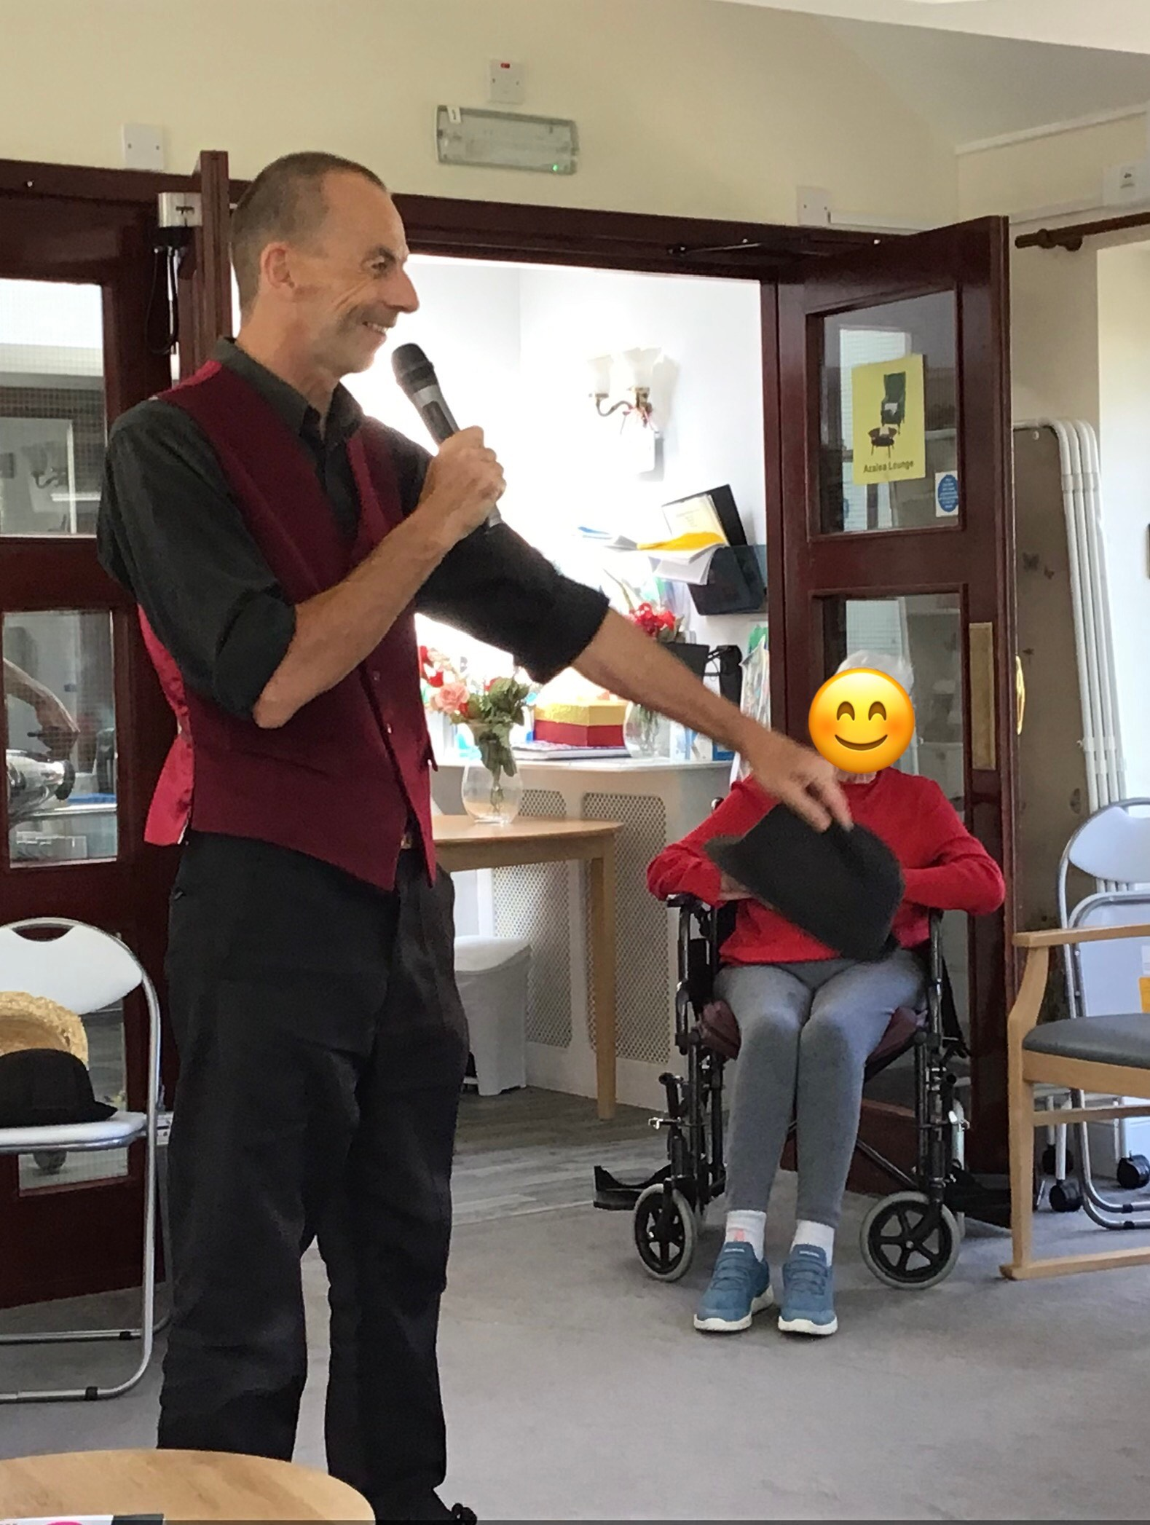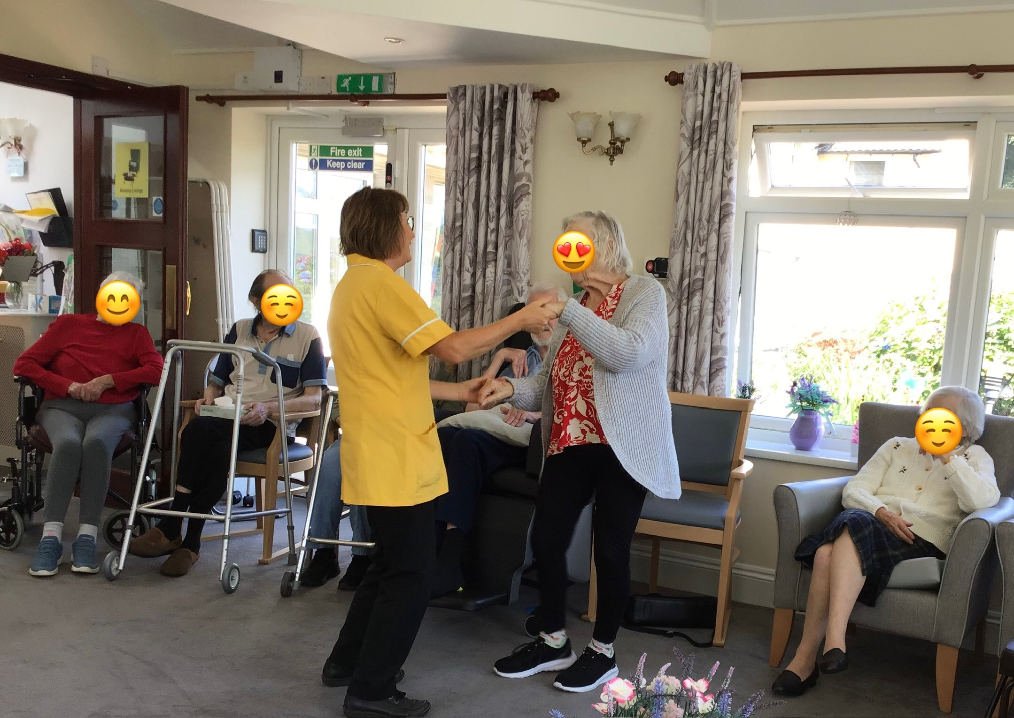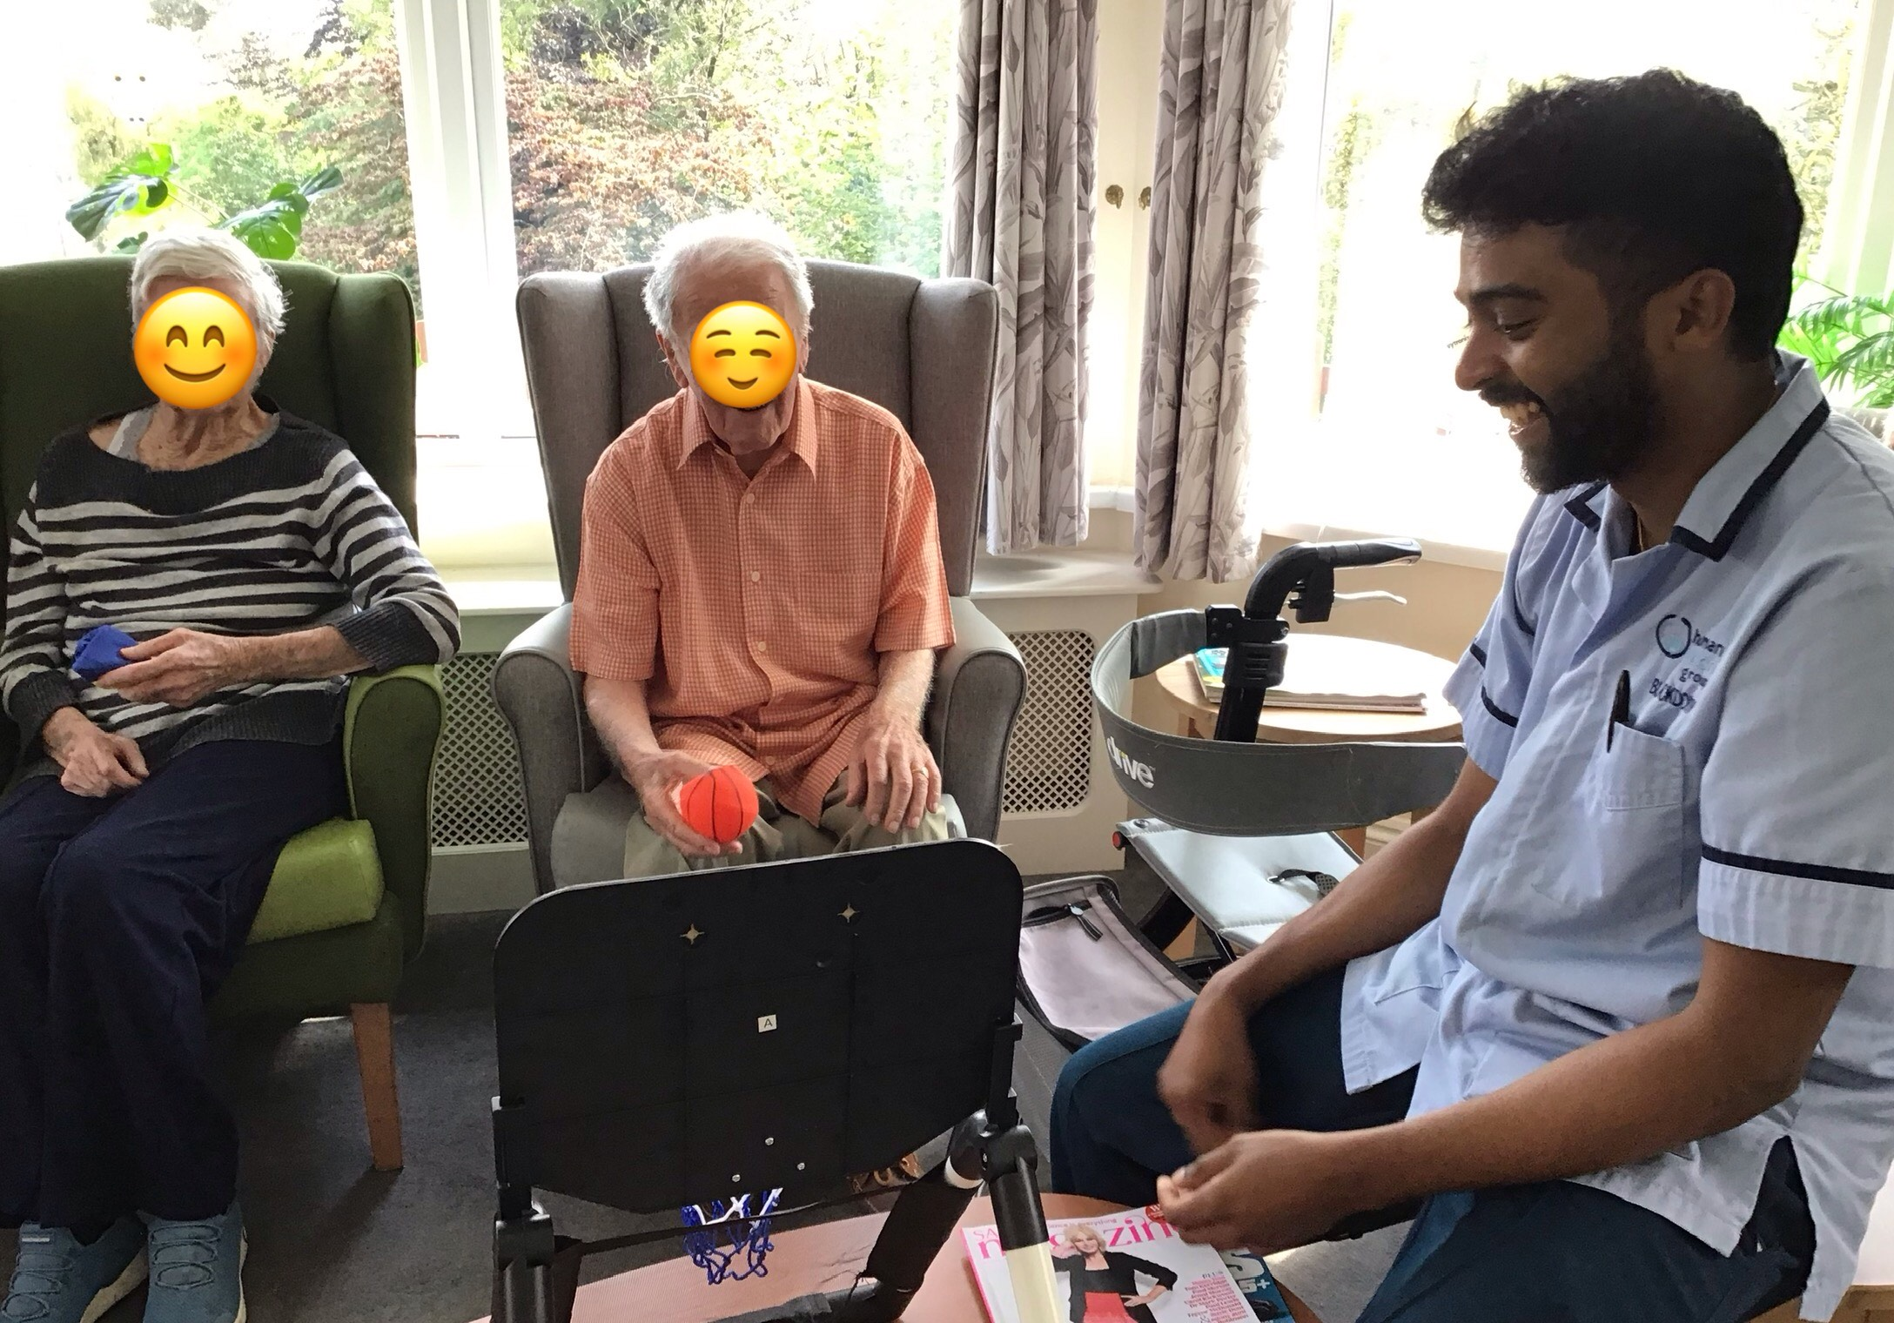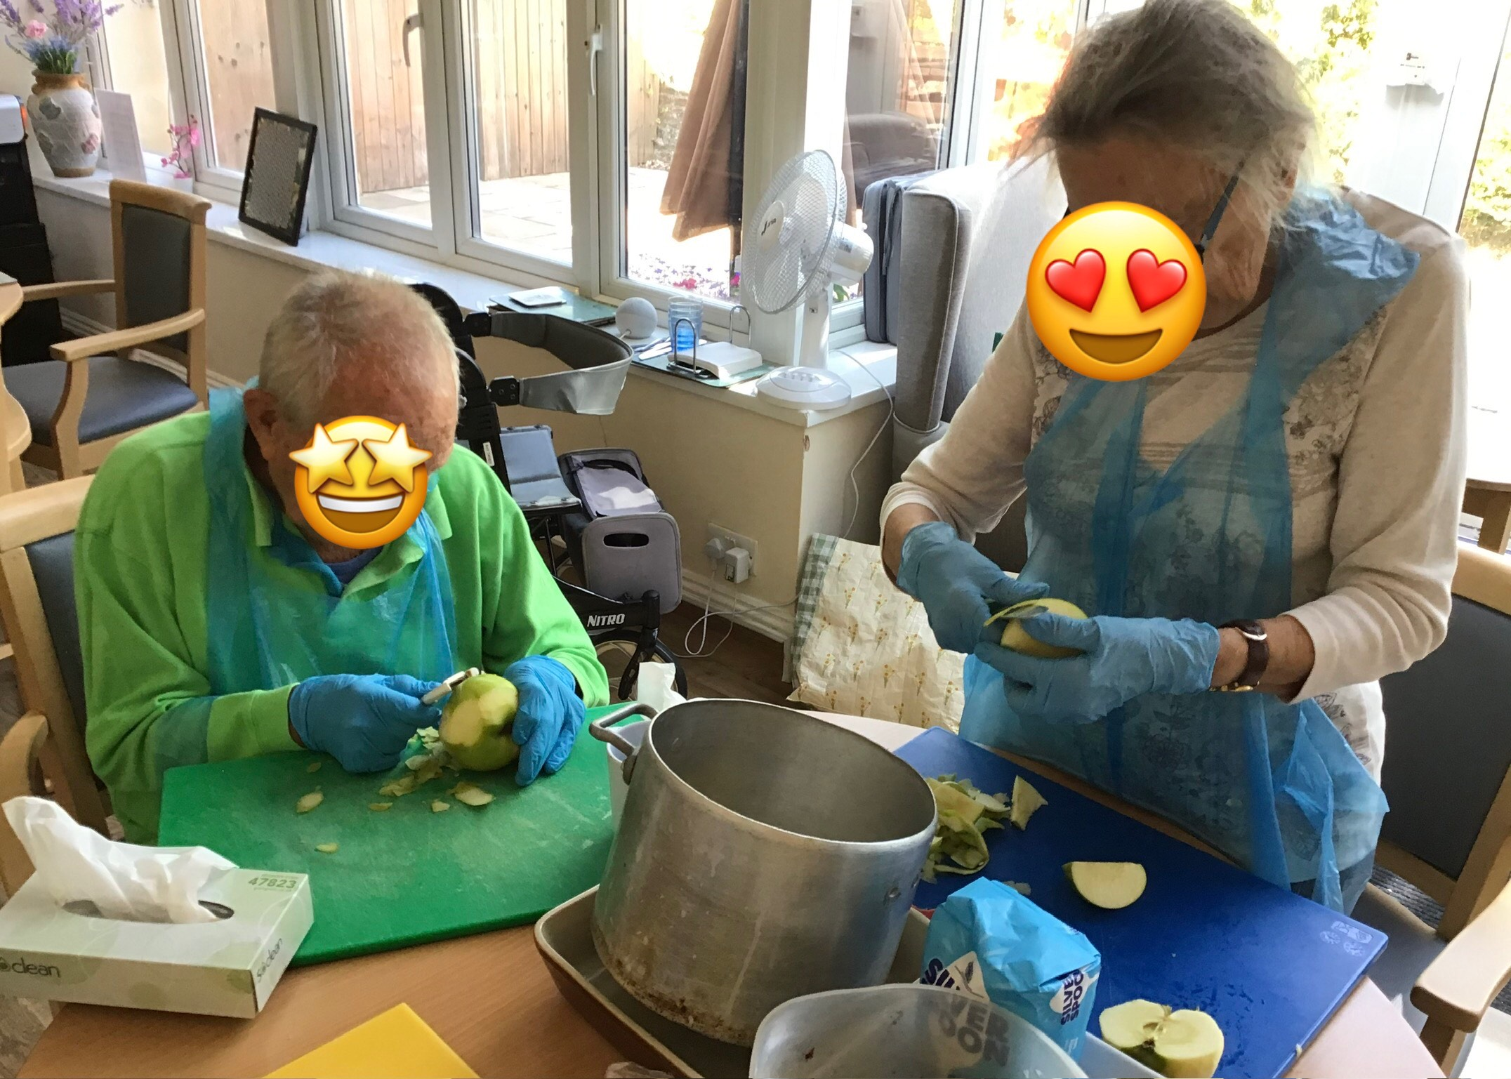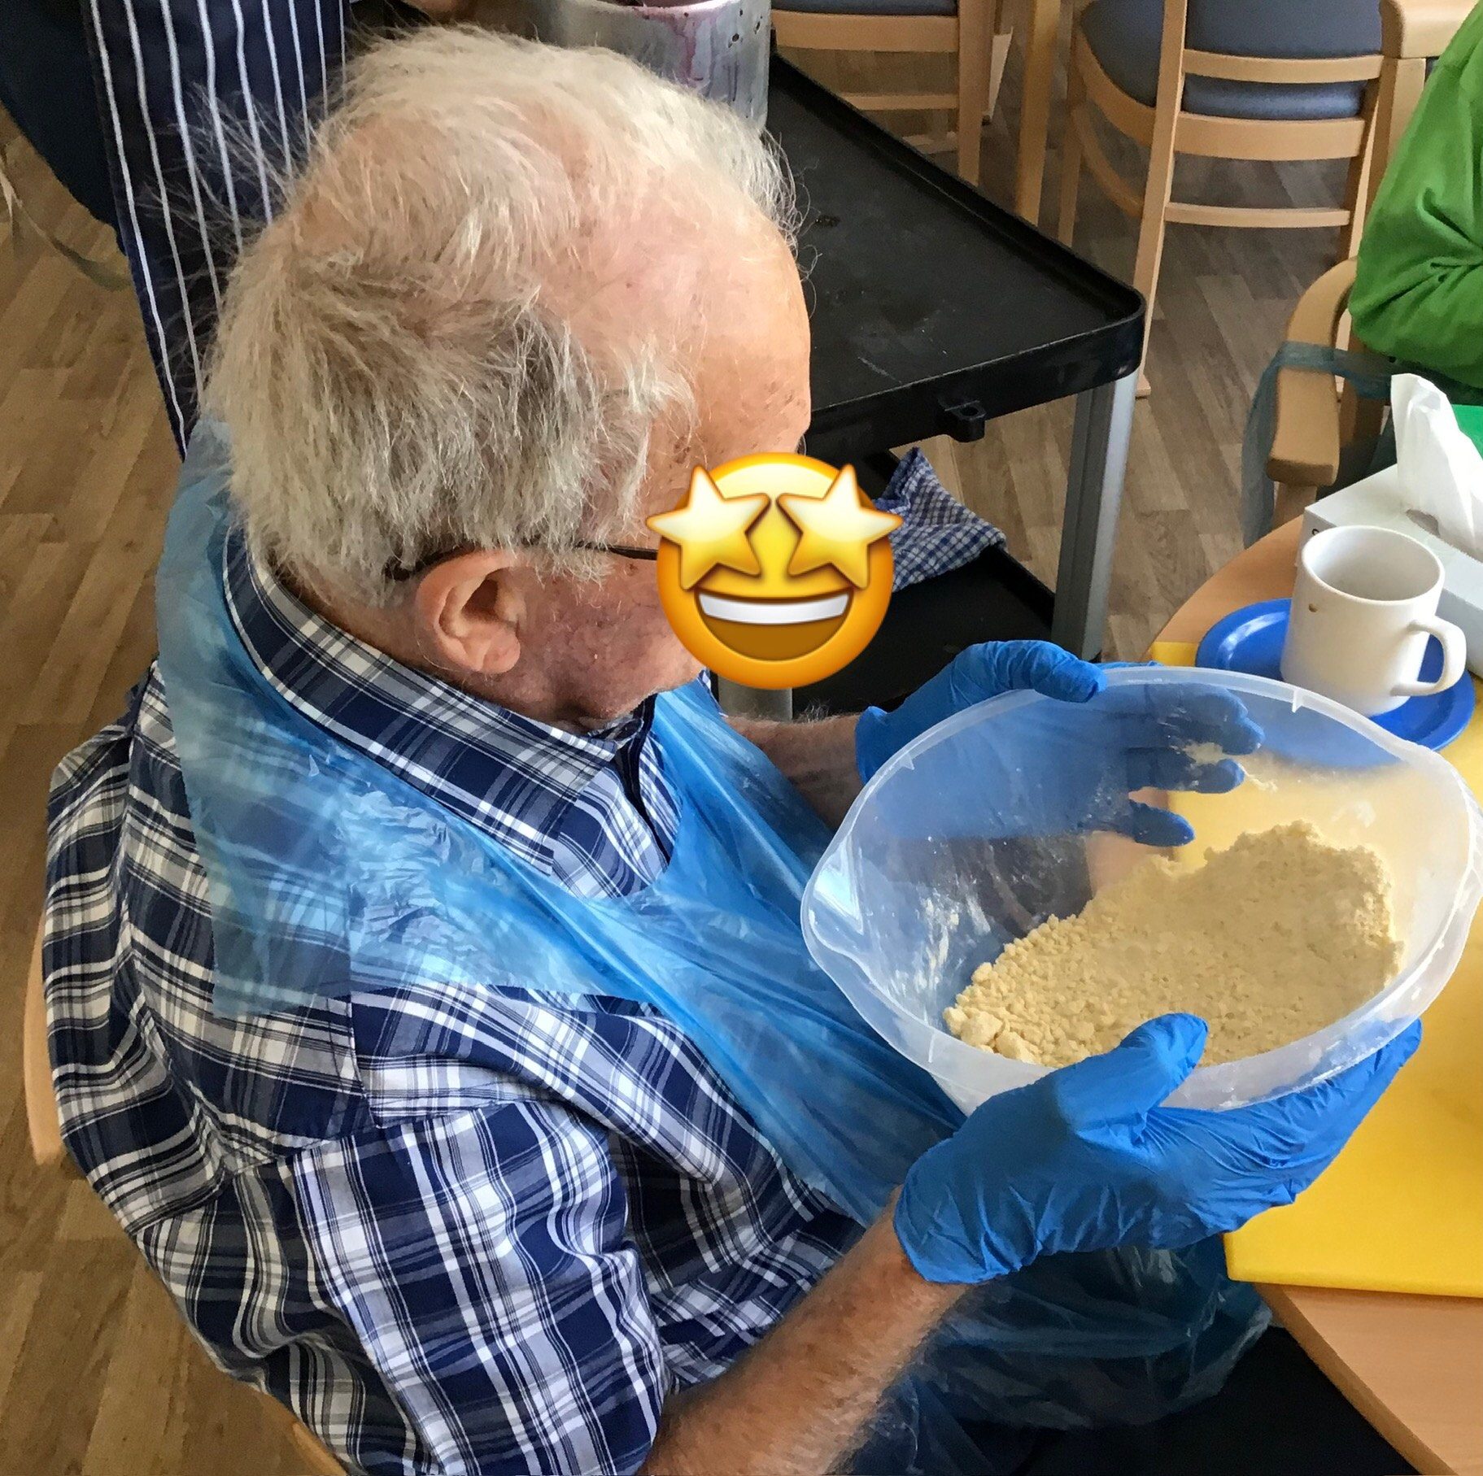

 Review us on carehome.co.uk

Please visit carehome.co.uk/submitreview or email reviews@carehome.co.uk

Thank you all for completing we are now on a fabulous 9.9

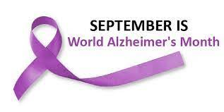

SEPTEMBER BIRTHDAY’S



Residents Staff
Pam 1st Leah 7th
Pat 5th Lisa 11th
Elsie 6th Mandy 17th
Ulanda 28th

